Poultry Disease Detector Report

# 1. INTRODUCTION

## 1.1 Project Overview

Poultry diseases can have devastating effects on the productivity and health of flocks, particularly in rural and commercial farming environments. This project presents a machine learning-based poultry disease classification system that can detect and classify common poultry diseases including Coccidiosis, New Castle Disease (NCD), Salmonella, and Healthy status. The system uses image-based inputs and provides users with real-time predictions through a web-based interface.

## 1.2 Purpose

The purpose of this project is to provide a cost-effective, fast, and accessible tool for poultry farmers and veterinary practitioners to identify poultry diseases, minimize outbreaks, and ensure animal well-being.

# 2. IDEATION PHASE

## 2.1 Problem Statement

Many poultry farmers lack access to immediate veterinary assistance, leading to delayed diagnosis and treatment of poultry diseases. This delay can cause the rapid spread of infections, reduced productivity, and economic losses.

## 2.2 Empathy Map Canvas

Users: Poultry farmers, veterinarians, students  
Needs: Fast, accessible diagnosis tool  
Pains: Inaccessible veterinary services, disease outbreaks  
Gains: Early detection, better flock management

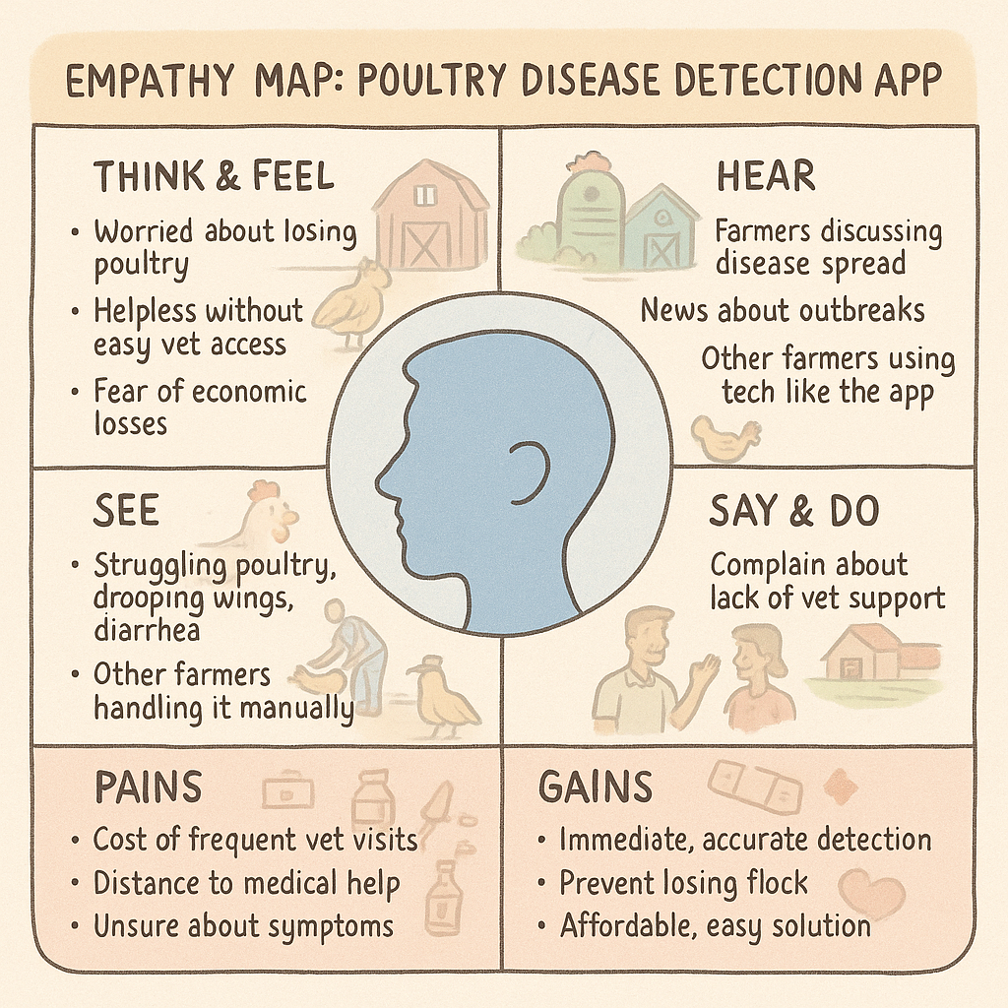

## 2.3 Brainstorming

- Mobile app for image-based disease detection  
- Dataset creation and labeling  
- Use of CNN and transfer learning  
- Web interface for disease prediction  
- Educational integration for veterinary students

# 3. REQUIREMENT ANALYSIS

## 3.1 Customer Journey Map

1. User observes symptoms in poultry  
2. Opens the web interface  
3. Uploads image of affected bird  
4. Gets prediction and guidance  
5. Applies treatment/preventive actions

## 3.2 Solution Requirement

- Image upload capability  
- Trained ML model (Keras/TensorFlow)  
- Dataset with 4 categories (Coccidiosis, NCD, Salmonella, Healthy)  
- Web framework (Flask)  
- Educational resource integration

## 3.3 Data Flow Diagram

1. Image Input  
2. Preprocessing  
3. Model Prediction  
4. Output Classification  
5. Suggestive Action Display

## 3.4 Technology Stack

- Frontend: HTML, CSS, JavaScript  
- Backend: Flask (Python)  
- Model: Keras + TensorFlow  
- Tools: Jupyter Notebook, VS Code

# 4. PROJECT DESIGN

## 4.1 Problem Solution Fit

The system bridges the gap between disease outbreak and diagnosis through real-time predictions, helping both large-scale farms and rural communities.

## 4.2 Proposed Solution

A web-based disease classification system powered by a CNN model trained on poultry disease images. Users can upload images to get predictions instantly.

## 4.3 Solution Architecture

- User uploads image through Flask web app  
- Image is preprocessed and passed to trained model

- Prediction is returned and displayed with confidence  
- Optional suggestions/treatment steps provided

# 5. PROJECT PLANNING & SCHEDULING

## 5.1 Project Planning

- Week 1: Ideation, Data Collection  
- Week 2: Model Training & Evaluation  
- Week 3: Web App Development  
- Week 4: Testing, UI Design & Deployment

# 6. FUNCTIONAL AND PERFORMANCE TESTING

## 6.1 Performance Testing

- Achieved overall accuracy of 90.18% on test data  
- Confusion matrix shows highest accuracy in classifying Healthy and Coccidiosis

# 7. RESULTS

## 7.1 Output Screenshots

- Home Page with Image Upload

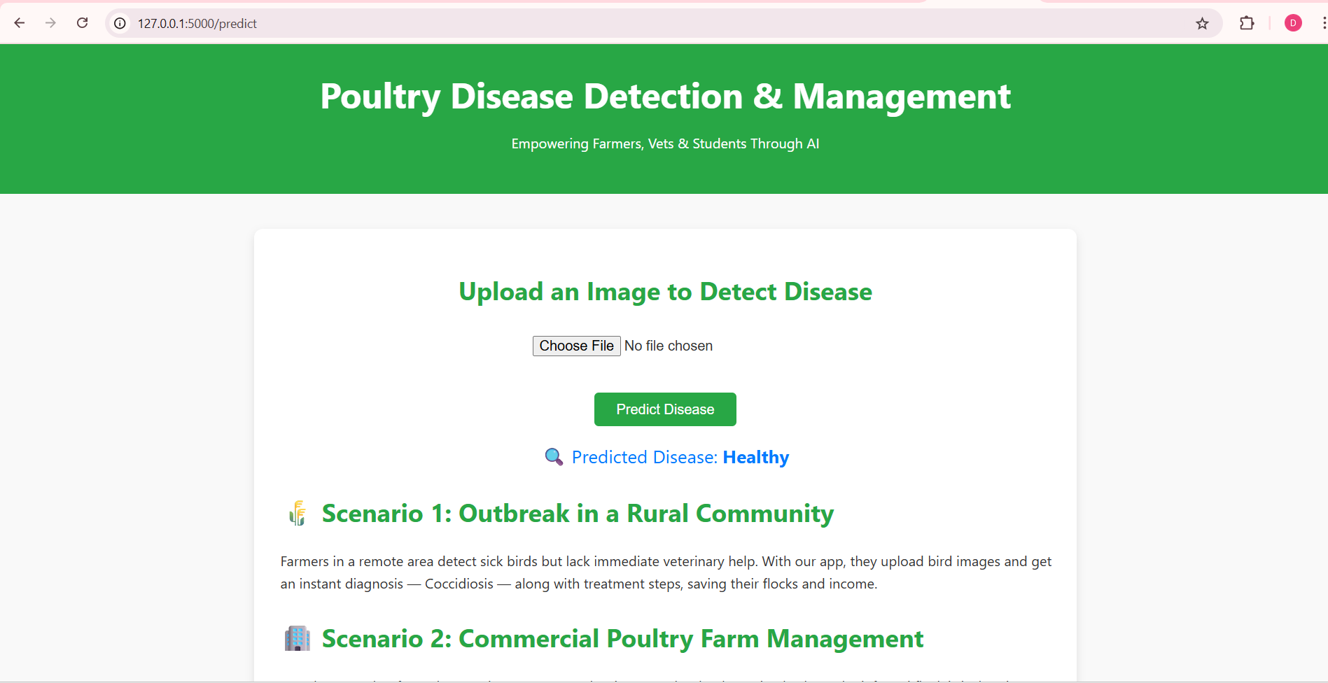

- Prediction Display (e.g., "Predicted: Coccidiosis")

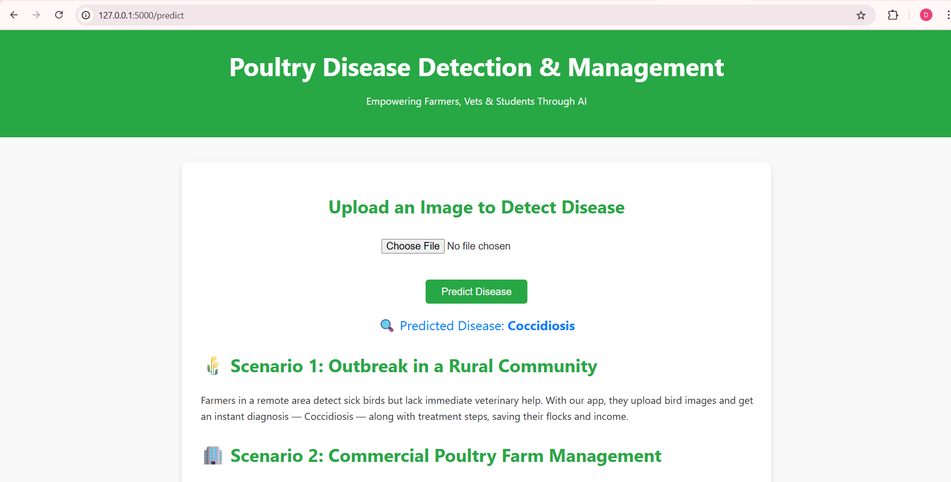

- Training Accuracy Graph  
- Confusion Matrix and Classification Report

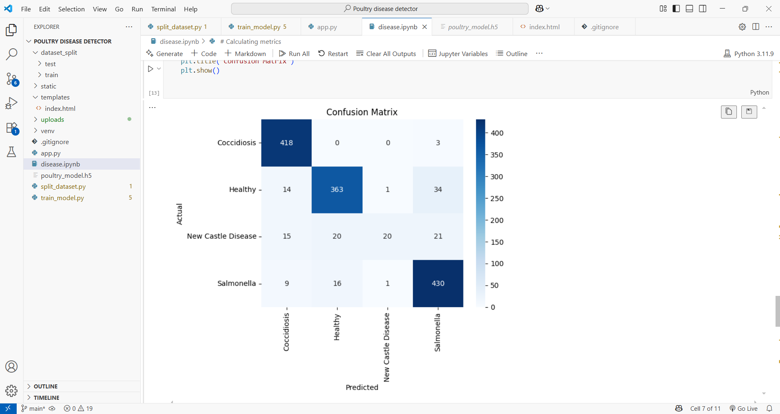

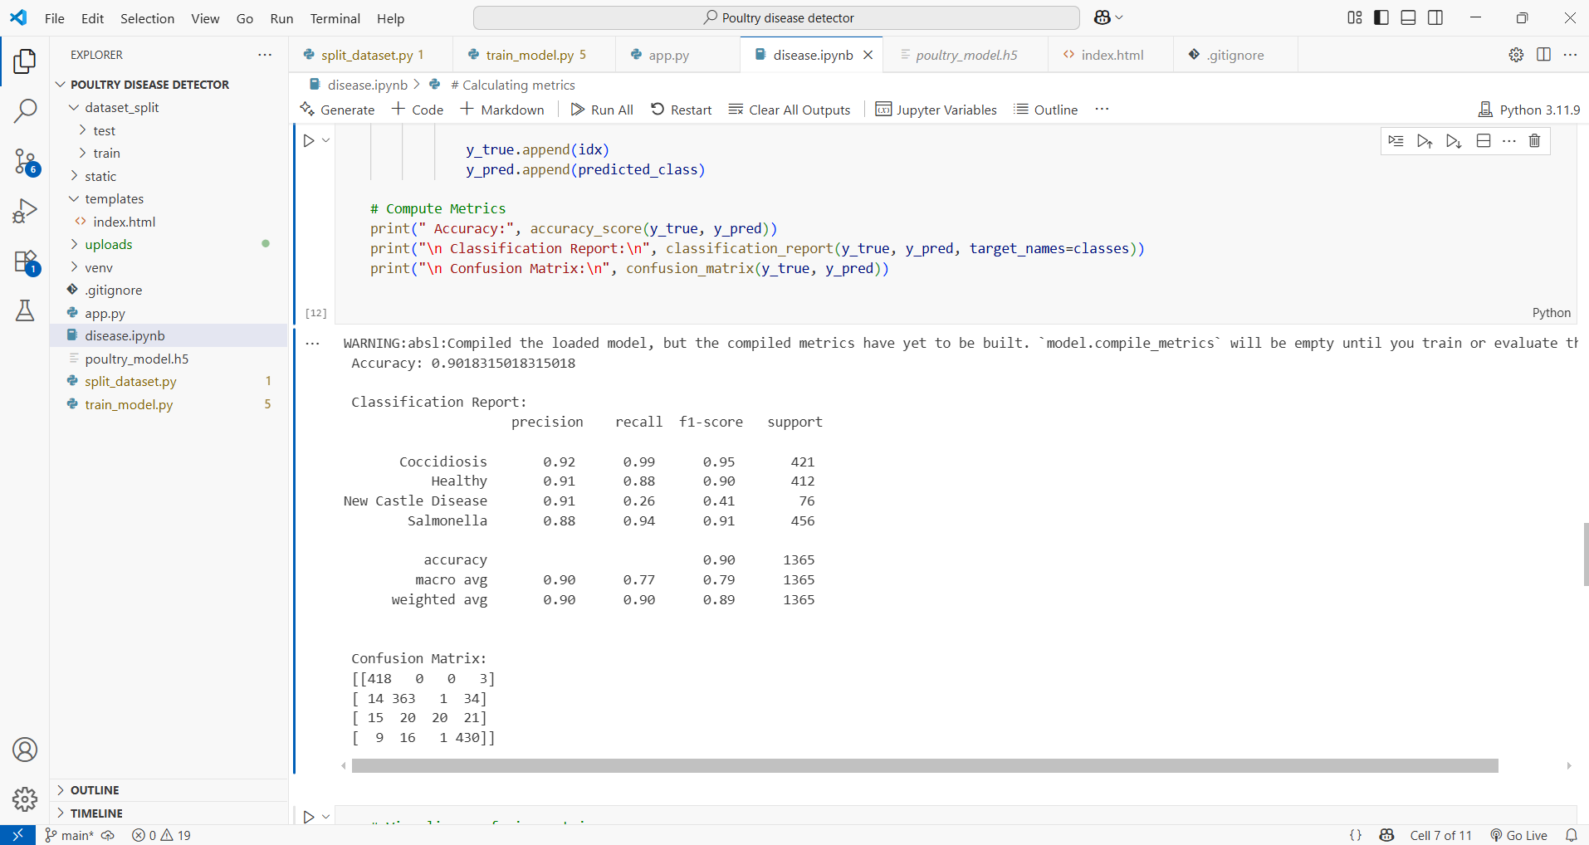

# 8. ADVANTAGES & DISADVANTAGES

Advantages:  
- Easy-to-use interface  
- Fast disease prediction  
- Useful in remote areas  
- Can be used for training veterinary students  
  
Disadvantages:  
- Accuracy dependent on image quality  
- Limited to four disease categories  
- Misclassification risk under poor lighting or visibility

# 9. CONCLUSION

This project demonstrates how AI can significantly aid poultry health management by enabling quick and accessible disease detection. It empowers rural communities and improves poultry farm productivity through timely disease classification.

# 10. FUTURE SCOPE

- Integrate voice/text-based symptom input  
- Expand to detect more poultry diseases  
- Multilingual support for rural users  
- Mobile app deployment with offline mode

# 11. APPENDIX

Source Code: Provided in GitHub  
Dataset Link: <https://www.kaggle.com/datasets/kausthubkannan/poultry-diseases-detection>  
GitHub Repo: <https://github.com/devisri36/Poultry-Disease-Detector>  
Demo Video Link: <https://drive.google.com/file/d/1dsaZNM9htdj7158j5z-S13lP05fhhRXo/view?usp=sharing>